Makro tø
Ugeseddel 1
1.
a) Inflation is an indicator of rising (spending and therefore) prices and affects income distributions and generates general uncertainty in the market high inflation forces regulatory actions by large actors
A to low inflation on the other is correlated to a higher unemploymentrate which is bad for the economys growth over all
These 2 factors amongst others amongst others make It so that most economists think a inflationrate between 1-4 is best
b)
the way governments react to high inflation is with higher intrestrates as this reduces spending and therefore prices(growth)
c) another way would be to increase taxes to reduce spending which ofcourse would lead to an unhappy populace
chap. 1
q3)
a)…
b) no since the gdp/pop is still much lower we can say that the standard of living would still be much lower
lul
c) they have improved their technology a whole lot mostly by bringing in foreign tech which is not an option for the us since they(for the most part are the ones sharing their technological advancements
q5)½

chap 2
q4)
 | Q1 | P1 | Q2 | P2 | q3 | P3 | S | diff
Y1 | 10 | 2000 | 4 | 1000 | 1000 | 1 | 25000
Y2 | 12 | 3000 | 6 | 500 | 1000 | 1 | 40000

$$Y_{12}=10·2000+4·1000+1000=25000=y_{1}·p_{1}$$
$$Y_{13}=12·3000+6·500+1000=40000=y_{2}·p_{2}$$
$$12·2000+6·1000+1000=31000:y_{2}·p_{1}$$
$$\frac{6}{25}=0,24$$
$$10·3000+4·500+1000=33000=y_{1}·p_{2}$$
- 60 % growth
- $\frac{6}{25}=0,24$
- $\frac{7}{33}≈0,2121212$
- Both are correct its just about which set of common prices are used
Q5)
- 2012 priser
$$\$Y_{t}=P_{t}·Y_{t}$$
2012
$$\frac{25}{25}=1$$
$$\frac{40}{31}≈1,290323$$
Diff $=29\%$
b)
$$\frac{25}{33}≈0,7575758$$
$$\frac{40}{40}=1$$
Diff $=$
c) both are correct again its about which common prices are used

Ugeseddel 2
Q2
$$C=480+\frac{1}{2}y_{d}$$
$$I=110$$
$$T=70$$
$$G=250$$
Per model
$$Y=C+I+G$$
$$Y_{d}=Y-T$$
$$Y=480+\frac{Y}{2}-35+110+250$$
$$Y=2·\left(480-35+110+250\right)=1610$$
$$Y_{d}=Y-70=1540$$
$$C=480+770=1250$$
Q3
Compute saving
$$S=Y_{d}-C=1540-1250=290$$
Public saving
$$PS=T-G=70-250=-180$$
$$I=S+PS=290-180=110$$
Solve for eq Y
- Is still $Y=1610$
- Let $G=300$ solve for output, consumption and disposable income again
$$Y=2·\left(480-35+110+300\right)=1710$$
$$Y_{d}=Y-T=1710-70=1640$$
$$C=480+\frac{Y_{d}}{2}=480+\frac{1640}{2}=1300$$
The increase in spending mens more income to consumers which again means more sepnding this mechanism repeats until new eq with a higher GDP

Q5
$$Z=C+I+G=c_{0}+c_{1}Y_{d}+I+G$$
$$=c_{0}+c_{1}\left(Y-T\right)+I+G$$
$$=c_{0}+c_{1}\left(Y-t_{0}-t_{1}·Y\right)+I+G$$
$$=c_{0}-t_{0}·c_{1}+\left(1-t_{1}\right)·Y+I+G$$
In eq
$$Y=c_{0}-t_{0}·c_{1}+c_{1}\left(1-t_{0}\right)·Y+I+G$$
$$Y+c_{1}\left(t_{1}-1\right)·Y=c_{0}-t_{0}·c_{1}+I+G$$
$$Y·\left(1+c_{1}·t_{1}-c_{1}\right)=c_{0}-t_{0}·c_{1}+I+G$$
$$=\frac{1}{\left(1+c_{1}·t_{1}-c_{1}\right)}·(c_{0}-t_{0}·c_{1}+I+G)$$
The multiplier is
$$\frac{1}{\left(1+c_{1}·t_{1}-c_{1}\right)}$$
A higher tax means a lower multiplier which means a lower growth given an increase in atonemous spending
When spending increases income increases but it increases less than if you weren’t taxed wich means a smaller compounding effect since less is going into the pockets of consumers

c.Why is fiscal policy in this case called an automatic stabilizer?
In case of lower spending the effect on the gdp will be lower since lower income means less tax which means a lower ripple effect in case of an economic downturn

Q6
A,b
$$Y=\frac{1}{\left(1+c_{1}·t_{1}-c_{1}\right)}·(c_{0}-t_{0}·c_{1}+I+G)$$
$$T=t_{0}+t_{1}·\frac{1}{\left(1+c_{1}·t_{1}-c_{1}\right)}·(c_{0}-t_{0}·c_{1}+I+G)$$
By a balnced budget I assume that $T=G$
c. output decrease and taxes decrease
d.
In the case where $c_{0}$ decreases where we before had the tax lowering which meant a lesser lowering of consumption which means the gdp is doing better
Now instead the money we chose to not take from consumption we instead lose directly from government spending which usually hits the economy harder since $c_{1}<1$ is assumed in that case the decrease in G is higher than the increase in C we get form the lowering of tax
It works as an accelerator

Us 3
C4
Q4
$$M^{d}=\$Y·\left(\frac{1}{4}-i\right)$$
$$M^{s}=8.000, \$Y=40.000$$
Find eq i
$$8.000=40.000·\left(\frac{1}{4}-i\right)$$
$$\frac{1}{5}=\left(\frac{1}{4}-x\right)$$
$$x=\frac{1}{20}=5\%$$
I rises to 10% what happens?
The demand for money decreases since opportunity costs of having money locked in bonds increase thus we will have a too high money supply to be in eq
A way a government could reach this new interstate coulb be to sell bonds at lower prices which increases the effective interest rate
i.e government buys bonds to dencrease rates
government sells bonds to increase rates

Q8
Public holds nothing
$$θ=0.1, M^{d}=\$Y(0.8-4·i)$$
$$H^{s}=100, \$Y=5.000$$
- What is the demand for central bank money?
$$H^{d}=θ·M^{d}$$
- Find eq interest rate
$$100=0.1·5000·(0.8-4x)$$
$⇕$ Ligningen løses for x vha. WordMat.
$$x=\frac{3}{20}=15\%$$
Find $M^{s}$
$$M^{s}=\frac{H^{s}}{θ}=1000$$
$$M^{d}=5000·\left(0.8-4·0.15\right)≈1000$$
Yes they are of course equal since we have only done legal menupulations
What happens to rates if $H^{s}=300$
$$300=0.1·5000·(0.8-4x)$$
$⇕$ Ligningen løses for x vha. WordMat.
$$x=\frac{1}{20}$$
We have a higher supply of money than before thus the rates much go down to encentevise the public to hold the extra cash
i.e if government buys bonds rates go down - expansionary open market operations
if government sell bonds rates go up - contractorary open market operations
per supply and demand

ext Q8
$$P=λ, B=1-λ$$
$$θ=0.1, M^{d}=\$Y(0.8-4·i)$$
$$H^{s}=100, \$Y=5.000$$
How much does the bank need in reserves as a func of $M^{d}$ and parameters
a)
$$R^{d}=θ·\left(1-λ\right)·M^{d}$$
b)
$$H^{d}=R^{d}+λ·M^{d}$$

$$H^{d}=θ·\left(1-λ\right)·M^{d}+λ·M^{d}=\left(λ+θ-λ·θ\right)·\$Y\left(0.8-4·i\right)$$
$$H=\left(λ+θ-λ·θ\right)·\$Y\left(0.8-4·i\right)$$
d)
$$100=\left(0+0.1-0·0.1\right)·5000·\left(0.8-4·x\right)$$
$⇕$ Ligningen løses for x vha. WordMat.
$$x=\frac{3}{20}$$
Den holder
- Let $λ=0.5$ what happens to interest rates?
Intuitions says that a change in rates will have
$$100=\left(0.5+0.1-0.5·0.1\right)·5000·\left(0.8-4·x\right)$$
$⇕$ Ligningen løses for x vha. WordMat.
$$x=\frac{21}{110}≈0,1909091$$

Idk bro
Q11
$$M^{d}=\$Y\left(0.25-i\right)$$
- $M^{d}$ when I=0
$$80·0.25=20$$
$$M^{s}≤20$$
- Negative renter bro

Central bank can print money even though people don’t care about holding money or holding bonds

By looking at the data we roughly see that money supply goes up as effective rates go down

Questions for the text
yes that is exactly the mechanism when government sells bonds the supply of bonds goes up and thus the price of bonds go down which increases the effective rate while locking up the value of the bond and thus removing it form the money supply

we expect money supply and rates to be inversely correlated so if we se increasing rates and increasing money supply it is weird

When rates increase it becomes less favorable to lend money thus “lending dries up”
Also it becomes better to invest in bonds because of the higher rates thus “short term deposits shrink”

Im not sure why things look bad?
Credit growth collapse means less lending means less spending means less economic growth

Us 4
C5 Q5
a)
$$Z=C+I+G$$
$$=100+0.3·\left(Y-T\right)+150+0.2Y-1000i+G$$
$$Y=100+0.3Y-0.3·T+150-1000·0.03+200$$
$$Y=100+0.5Y-0.3·100+150-1000·0.03+200$$
$⇕$ Ligningen løses for Y vha. WordMat.
$$Y=780$$

b)2
I is the rate that the central bank sets

$$\frac{M}{P}=2Y-4000i$$
$$\frac{M}{P}=780·2-120=1440$$
$$C=100+0.3\left(780-100\right)=304$$
$$I=150+\frac{780}{5}-1000·0.03=276$$
- $\frac{M}{P}=1500$
$$Y=100+0.3·\left(Y-100\right)+150+0.2Y-1000·n+200$$
$$1500=2Y-4000·n$$
$⇕$ Ligningssystemet løses for Y,n vha. 's 'Løs Ligninger' funktion,
$$Y=795;n=\frac{9}{400}$$

The output as a function of interest rate is pushed up thus we need lower interest rate to get the same output
The mechanism goes
As money supply increases people have more money left over thus more to invest thus demand for bond increase and interestrates fall
Lower interest means higher interest which means higher output which leads to lower interestrates the continues until eq
$$I=150+795·0.2-\frac{9}{400}·1000=286,5$$
$$C=100+0.3(795-100)$$
- Given the central bank decides to keep constant interest rates
$$Y=100+0.3·\left(Y-100\right)+150+0.2Y-1000·n+300$$
$$1500=2Y-4000·n$$

If G goes up output goes up which leads to increases in spending and investment until eq
Money supply on the other has to go up as output increases to keep interestrates stable

Q5
$$IS: Y=C\left(Y-T\right)+I\left(Y,i-π+x\right)+G$$
$$LM_{1}: i=i^{'}$$
$$LM_{2}:r^{'}=i-π$$

- Probably % in is interestrate after all
- 2%
- Expected inflations goes down which means real interestrate goes up which means money demand goes down
Thus to stay in eq money supply must go down I.E gov buy bond interest goes down
Decrease interestrates by the same amount
- When we let $LM_{2} bind$
No but we do move up the curve
- Yes as the effective rate increases the LM curve shifts
- When x changes the LM relation stays in the same place so no the LM curve doesn’t move
- But the IS curve shifts
- (fiscal) If we want output to stay the same when riskpremium increases we increase government spending
- (Monetary) we decrease the interest rate
Q8
$$\left(1+i\right)=\left(1-p\right)\left(1+i+x\right)$$
- X=0
- Udregn
$$\left(1.03\right)=\left(1-p\right)·(1.08)$$
$⇕$ Ligningen løses for p vha. WordMat.
$$p=\frac{5}{108}≈0,0462963$$
4.6%
c) u
$$1.04=0.99·(1+x)$$
$⇕$ Ligningen løses for x vha. WordMat.
$$x=+\left(\frac{5}{99}\right)$$
$$5.050505\%$$

$$1.04=0.95·(1+x)$$
$⇕$ Ligningen løses for x vha. WordMat.
$$x=\frac{9}{95}≈0,09473684$$
9.5%
$$\left(1+i\right)=\left(1-p\right)\left(1+i+x\right)+p·a$$
A er forsikringsrate

Us 5

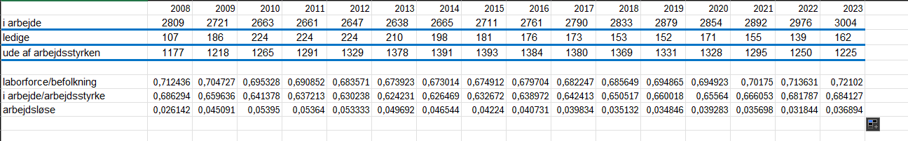
Efter finanskrisen gik arbejdsløsheden en del op i de næste 2 år
Lidt forkert vi vil have arberjdsløse/laborforce i stedet for arbløse/befolkning

Q3. The natural rate of unemployment
Suppose that the markup of goods prices over marginal cost is 5%, and that the wage-setting equation is
$$W =P(1- u)$$

where u is the unemployment rate.
- What is the real wage, as determined by the price-setting equation?
$$P=\left(1+m\right)·W$$
$$\frac{W}{P}=\frac{1}{1+0.05}=0,9523809523809523$$
- What is the natural rate of unemployment?
$$=1-0,9523809523809523=0,04761904761904767$$
$$=4.8\%$$
- Suppose that the markup of prices over costs increases to 10%. What happens to the natural rate of unemployment? Explain the logic behind your answer
$$\frac{1}{1+0.1}=0,9090909090909091$$
$$u=9\%$$
Hvis firmaet kan lave større markup må de producere mindre og få samme profit derved skal de bruge mindre arbejdskraft og derved stiger arbejdsløsheden

Q4.Reservation wages
In the mid-1980s, a famous supermodel once said that she would not get out of bed for less than $10,000 (presumably per day)
- What is your own reservation wage?
200kr/t
- Did your first job pay more than your reservation wage at the time?
More otherwise I wouldn’t have worked per the definition
- Relative to your reservation wage at the time you accept each job, which job pays more: your first one or the one you expect to have in 10 years?
The one in 10 years
- Explain your answers to parts (a) through (c) in terms of the efficiency wage theory.
- just a estimate I don’t really se the reason for the question
- as stated if the wage was lower than my reservation wage I wouldn’t have worked wage should also incompas the monetary value of all compensation
- Part of the policy response to the crisis was to extend the length of time workers could receive unemployment benefits. How would this affect reservation wages if this change was made permanent?
The reservation wage would all else equal increase as the benefit to working compared to not working would go down at least for the extended period

Q10.
The typical dynamics of unemployment over a recession
Go to IMF data mapper (http://www.imf.org/external/datamapper/datasets). Select the
following countries- France, Germany, the UK, Spain, Japan, and the US.
Build a table to compare each country’s GDP annual growth rate and the unemployment rate for the period: 1980-2020.

Country |  | France |  |  | Germany |  |  | Spain |  |  |  | UK
Year |  | GGR |  | uL | GGR |  | UL |  | GGR |  | UL | GGr | UL
1981  1982  1983 |  | 1.8  1.1  2.5 |  | 6,3  7,4  8,1 | 1.3  0.1  -0.8 |  | 4,8  6,7  8,1 |  | -0.4  1.2  1.7 |  | 13,8  15,8  17,2 | -0.7  2  4.2 | 9,7  10,7  11,5
1991  1992  1993 |  | 1  1.6  -0.6 |  | 8,6  9,4  10,3 | 5  1.9  -1 |  | 5,5  6,6  7,8 |  | 2.5  0.9  -1.3 |  | 16,3  18,4  22,6 | -1.4  0.2  2.3 | 8,9  10  10,4
2008  2009 |  | 0.3  -2.9 |  | 7,4  9,1 | 1  -5.7 |  | 7,4  7,2 |  | 0.9  -3.8 |  | 11,2  17,9 | -0.2  -4.6 | 5,7  7,6
2012  2013  2014 |  | 0.3  0.6  1 |  | 9,8  10,3  10,3 | 0.4  0.4  2.2 |  | 9,8  10,3  10,3 |  | -3  -1.4  1.4 |  | 24,8  26,1  24,4 | -1.5  -1.8  3.2 | 8  7,6  6,2
 | japan |  |  |  | US
 | GGR |  | UL |  | GGR | UL
 | 4.3  3.3  3.6 |  | 2,2  2,4  2,7 |  | 2.5  -1.8  4.6 | 7,6  9,7  9,6
 | 3.5  0.9  -0.5 |  | 2,1  2,2  2,5 |  | -0.1  3.5  2.8 | 6,9  7,5  6,9
 | -1.2  -5.7 |  | 4  5,1 |  | 0.1  -2.6 | 5,8  9,3
 | 1.4  2  0.3 |  | 4,3  4  3,6 |  | 2.3  2.1  2.5 | 8,1  7,4  6,2

- When is the unemployment rate during the four recessions higher, during the year of declining output or the following year? Explain why.
The year after
If demand goes down firms scale down in production thus hirering less and thus unemployment increases
- Explain the patterns in the four European countries with regard to the evolution of unemployment and the evolution of the GDP growth.
Jeg ved ikke hvad han fisker efter
- Compare the data for Japan and the US with the data for the European countries. Comment on the differences you see, if any, with the European countries.
Fatter stadig ikke hvad han fisker efter…

US 6
Artikel opgaver
A
Bargaining power usually is determined by a function F such that
$$W=P·F\left(u,z\right)$$
Where f is decreasing in unemployment and increasing(without loss of enerality) in z which is a catch all variable
Why has the bargaining power decreased?
A decline in bargaining power must either come from an increase in unemployment or a worsening of other market conditions
The article states that a “renowned” economist says that workers are returning to the labor market from thus raising unemployment thus decreasing bargaining power and thus wages
B
When bargaining power decreases the the real wage must also decrease because a worker who wants to negotiate salary is in a worse spot over all (worse unemployment benefits)
i.e he is more replacable since there are more workers wanting to take his place

C
D
If $\overline{π}>0,π<0→π-\overline{π}<0→Y-Y_{n}<0$
Kan ikke sige noget om størrelsen
E
If the government doesn’t raise rates the inflation will become deancored from their inflation target thus
$$π^{e}=\overline{π}→π_{t}^{e}=π_{t-1}$$
When inflation isent being controlled by the government the people expect it to be as last year
If $π_{t-1}<0$
$$p_{t}^{e}<p_{t-1}^{e}→higher unemployment→lower output→higher deflation, again untill EQ$$
When government doesn’t react this leads to lwer output every year
F
Government should encourage spending thus increasing output and thus getting higher inflation and lower unemployment

C8Q6
$$π_{t}=0.1-0.08=0.02$$
$$π_{t+1}=0.1-0.08+0.02=0.04$$
$$π_{t+k}=0.02·k$$
Let half be index waged
Before we must have had
$$π_{t}-π_{t-1}=-α·(u_{t}-u_{n})$$
now
$$π_{t}=λπ_{t}+\left(1-λ\right)π_{t-1}-α\left(u_{t}-u_{n}\right)$$
$$\frac{1}{2}·\left(π_{t}-π_{t-1}\right)=0.1-2u_{t}$$
$$\left(π_{t}-π_{t-1}\right)=0.2-4u_{t}$$

Compute as part 1
$$π_{t}=0.2-4·0.04≈0,04$$
$$π_{t+1}-0.04=0.2-4·0.04+0.04=0.08$$
$$π_{t+k}=0.04·k$$
Given the equation
It makes inflation more sensitive to changes in unemployment
Since if you are employed and prices change youll spend more and thus inflation rises more
It serves to accelerate inflation/deflation

C9 Q4
- $π_{t}^{e}=0.02$ via the situation described above
When output $c_{0}$ increases output increases thus inflation must increase
So both outpu and inflation is higher than last year
Let inflation be completely deancored
- All else equal
If $π_{t+2}^{e}=π_{t+1}$
$$π_{t+2}-π_{t+1}=π_{t+2}-π_{t+2}^{e}=\frac{α}{L}·\left(Y_{n}-Y\right)=α(u_{n}-u)$$
$$Y-Y_{n}=L(u-u_{n})$$
$$Skriv ligningen her.$$
Given at least the same output
If output is the same then inflation must also be the same
Inflationen følger output
- Is it sustainable in the long run?
This is exactly as when the expected inflation is completely deancored
Thus accelerating
Q5
- Again we assume that
$$π_{t+1}^{e}=π_{t}$$
Assume $\overline{π}=π_{n}^{e}$ for the the rest of this exercise
Oilprices increase in t and government doesn’t change rates. What happens in period t+1?
We notice that $P_{t}>P_{t}^{e}→π_{t+1}>π_{t+1}^{e}=\overline{π}$
$$→Y>Y_{n}$$
- pas
- this is fine we just have a constant offset in prices giving us slightly higher inflation but inflation doesn’t really care in the other periods

tutorial 7
q3
$$Y=K+2N$$
$$10+40=50$$
It triples
Constant returns to scale
$$\frac{Y}{N}=\frac{K}{N}+2$$
No it doesn’t double
Se falling marginal productivity I e per assumption
No its decreasing returns to scale
One were looking at total production where in the other were looking at production per capita, the intuition says if 2 people have the same resources they are equally productive but one person will be lass than twice as productive, the same if 2 people share reasorces they are gonna be more procutvie than 1 person with all the reasoruces but less productive than if they both had the original level
In the function given the relationship is linear sating that given no resources a person is still productive which I guess could make sense since we could rent out pure laborforce to another country

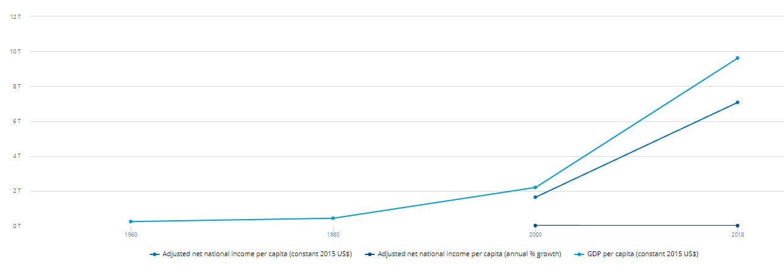
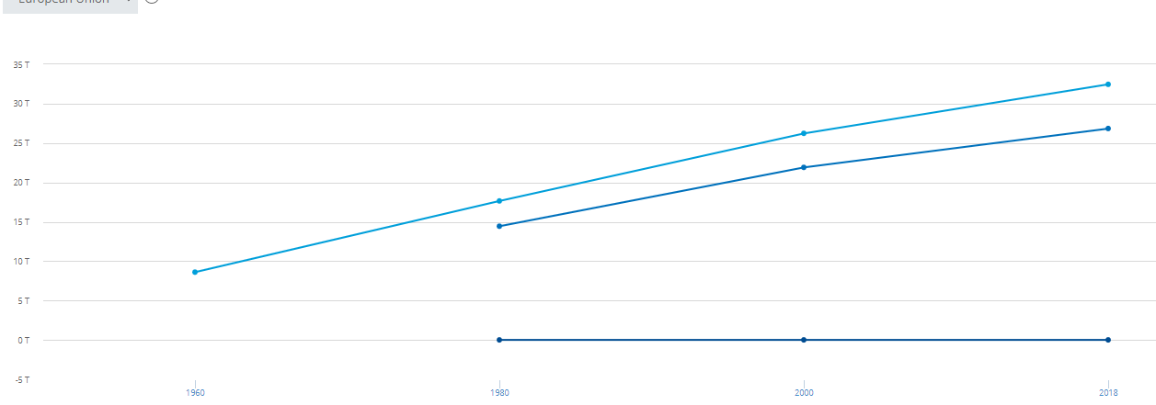
$${1.06}^{20}≈3,207135$$
$${1.01}^{20}≈1,22019$$
Hvis vi siger er eu zonen har $\frac{gdp}{Y}=30$
Kina: $10$
Givet hvad han siger vil kina været catchet helt op

Q6
$$Y=3·\sqrt{K}·\sqrt{N}⇔\frac{Y}{N}=3·\sqrt{\frac{K}{N}}$$
Steady state gives us
$$s·\frac{Y}{N}=δ·\frac{K}{N}$$
$$s·3·\sqrt{\frac{K}{N}}=δ·\frac{K}{N}⇔{\left(\frac{s}{δ}·3\right)}^{2}=\frac{K}{N}$$
$$\frac{Y}{N}=\frac{s}{δ}·3^{2}$$
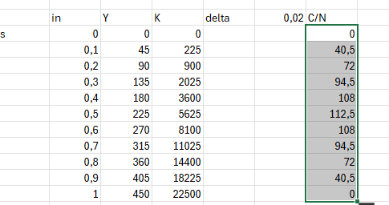

Q8
$$Y=K^{\frac{1}{3}}·N^{\frac{2}{3}}$$
$$\frac{Y}{N}={\left(\frac{K}{N}\right)}^{\frac{1}{3}}$$
$$s=δ=0.1$$
Steady state:

$$s·{\left(\frac{K}{N}\right)}^{\frac{1}{3}}=δ·\frac{K}{N}$$
$$\frac{s}{δ}={\left(\frac{K}{N}\right)}^{\frac{2}{3}}$$
$$\frac{K}{N}=1$$
$$\frac{Y}{N}=1$$
Now $δ=0.2$
Steady state:
$$\frac{s}{δ}={\left(\frac{K}{N}\right)}^{\frac{2}{3}}⇔\frac{K}{N}={\left(\frac{1}{2}\right)}^{\frac{3}{2}}=\frac{1}{2^{\frac{3}{2}}}≈0,3535534$$
$$\frac{Y}{N}=\frac{1}{\sqrt{2}}$$
Ugeseddel 8
Chapter 12
$$Y=K^{α}·AN^{1-α}$$
$$\frac{Y}{AN}=$$
$$s=0.16,δ=0.1,g_{n}=0.02,g_{A}=0.04$$
In eq
$$s·\frac{Y}{AN}=(δ+g_{n}+g_{A})·\frac{K}{AN}$$
$$s·\frac{K^{α}}{AN^{α}}=\left(δ+g_{n}+g_{A}\right)·\frac{K}{AN}$$
$$\frac{K^{α-1}}{AN^{α-1}}=\frac{\left(δ+g_{n}+g_{A}\right)}{s}$$
$$\frac{K}{AN}={\left(\frac{\left(δ+g_{n}+g_{A}\right)}{s}\right)}^{\frac{1}{α-1}}={\left(\frac{s}{δ+g_{n}+g_{a}}\right)}^{\frac{1}{-a}}$$
$$\frac{K}{AN}={\left(\frac{\left(δ+g_{n}+g_{A}\right)}{s}\right)}^{\frac{1}{α-1}}={\left(\frac{\left(0.1+0.02+0.04\right)}{0.16}\right)}^{-2}=1$$
$$\frac{Y}{AN}=1$$
Growth of $\frac{Y}{AN}=0$
Gr0wth of $\frac{Y}{N}=g_{A}=0.04$
$$growth of Y=g_{A}+g_{n}=0.06$$
B) $g_{A}=0.02$ what happens?
$$\frac{K}{AN}={\left(\frac{\left(δ+g_{n}+g_{A}\right)}{s}\right)}^{\frac{1}{α-1}}={\left(\frac{\left(0.1+0.02+0.02\right)}{0.16}\right)}^{-2}≈1,306122$$
$$\frac{Y}{AN}=\sqrt{\frac{K}{AN}}={\left(\frac{\left(0.1+0.02+0.02\right)}{0.16}\right)}^{-1}≈1,142857$$

Gr0wth of $\frac{Y}{N}=g_{A}=0.02$
Growth of$Y=g_{A}+g_{n}=0.04$
When technological growth decreases overall growth decreases then
- $g_{A}=0.04, g_{N}=0.06$
$$\frac{K}{AN}={\left(\frac{\left(0.1+0.06+0.04\right)}{0.16}\right)}^{-2}=0,64$$
$$\frac{Y}{AN}=\frac{0.16}{0.20}≈0,8$$

Gr0wth of $\frac{Y}{N}=g_{A}=0.04$
Growth of$Y=g_{A}+g_{n}=0.10$
Since A grows at the same rate given same starting point in tech
$${\frac{Y}{AN}}_{c}>{\frac{Y}{AN}}_{A}⇒\frac{Y}{N_{C}}>\frac{Y}{N_{a}}⇒\left(1-s\right)·\frac{Y}{N_{c}}>(1-s)·\frac{Y}{N_{A}}$$
Which means country c will be richer in the long run meaning more
Given a cobb douglass economy we have
$$g_{Y}=α·g_{K}+\left(1-α\right)·g_{A}+\left(1-α\right)g_{N}$$
$$\left(1-α\right)·g_{A}=g_{y}-α·g_{k}-\left(1-α\right)·g_{N}=g_{Y}-g_{N}-α(g_{k}-g_{N})$$
What does $g_{y}-g_{N}$ reprecent?
The growth not coming from a increase in population = growth of output per worker
What about $g_{k}-g_{n}$ the growth coming from a increase in kapital/worker

 | 2000 |  |  |  | 2014
 | y | n | k | Share of labor | y | n | k | Share of labor
China | 5420107 | 736 | 13034514 | 1 | 17369238 | 1399 | 70822720 | 1
us | 14110581 | 139 | 49329068 | 1 | 18244220 | 148 | 64118460 | 1
Labor share doesn’t make any sense in the dataset
Over the 14 years k/n has been steadily rising in the us though there has been some stagnation in the later years(o or sometimes negative investment/worker while china is still going strong
Labor share is 1 I don’t really understand the point

RND
- RnD spending is important because technological is one of the factors which provide continuous growth
If approbiability or fertility increases it makes it more profitable for firms to invest in RnD and thus increases the amount the firm wants to invest
Approbiability meaning the profibitability of discovery
And fertility the likelihood to discover something profitable I. e discovery/dollar spent is higher
- Tax credits reduce the effective dollar spend thus increasing the fertility indirectly
- Given increase in tech growth what happens
In eq we have
$$s·\frac{Y}{AN}=\left(δ+g_{A}+g_{N}\right)·\frac{K}{AN}$$
$\frac{K}{AN} decreses see drawing$since concave ie decreasing returns to scale

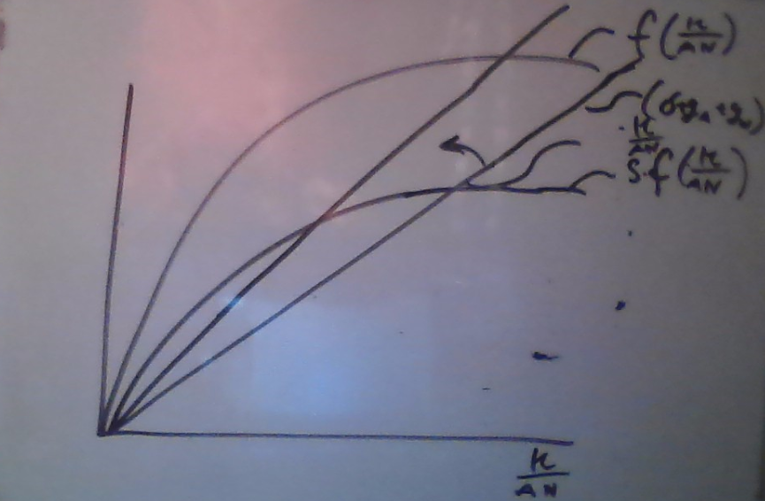

By the same drawing $\frac{Y}{AN}$ also decreases
Growth of $\frac{Y}{AN}=0$
Growth of $\frac{Y}{N}$ increases since if $\frac{Y}{AN}$ is constant then if $A$ is increasing faster then $\frac{Y}{N}$ must increase as fast for $\frac{Y}{AN}$ to remain constant
Growth of Y must also increase since $Y=F(K,A,N)$ if A grows faster then Y must grow faster

What would happen if we see a one time jump in technology
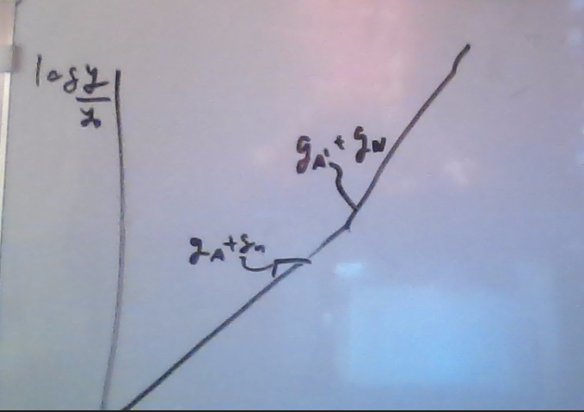
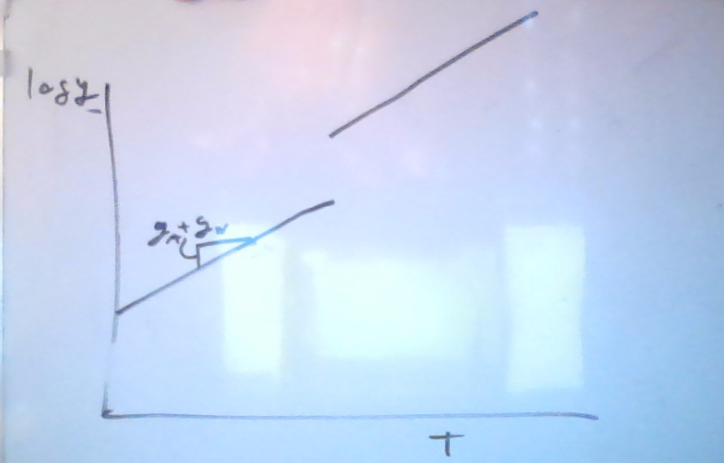

US 9
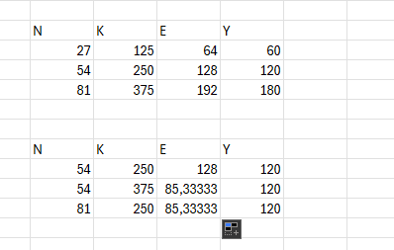
C) well its not entirely correct its more that if N and K increases well se diminishing returns to scale unless we increase energy consumption
D)
Q6
If rates increase stockprices fall since the future cashflows are discounted at a higher rate
$$Q_{t}=\frac{D_{1}}{1+r_{f}^{1}+x}+\frac{D_{2}}{\left(1+r_{f}^{1}+x\right)\left(1+r_{f}^{2}+x\right)}+…$$
If the rete increase is expected to persist then the future expected rates will also be higher thus driving prices further down
If dividends increase at the same rate as rates then prices will stay roughly the same

Q7
$$p_{b}=\frac{60}{{\left(1+0.05+0.05\right)}^{3}}=45,078888054094655$$
$$p_{s}=\frac{20}{1+0.05+0.10}+\frac{20}{{\left(1+0.05+0.10\right)}^{2}}+\frac{20}{{\left(1+0.05+0.10\right)}^{3}}=45,66450234240157$$
If they are priced equally we should buy the bond rather than the stock
$$p_{s}=\frac{20}{1+0.05+0.05}+\frac{20}{{\left(1+0.05+0.05\right)}^{2}}+\frac{20}{{\left(1+0.05+0.05\right)}^{3}}=49,73703981968444$$
Then we would rather buy the stock
$$p_{s}=\frac{20}{1+0.05+0.10}+\frac{20}{{\left(1+0.08+0.10\right)}^{1}·1.15}+\frac{20}{1.15·1.18·1.22}=44,21034828515168$$
$$p_{b}=\frac{60}{1.15·1.18·1.22}=36,24195126665621$$
Now would
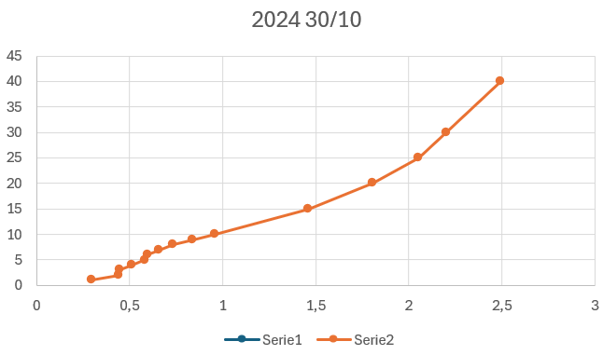
Us 10
Artikel spørgsmål:
- The islm curve predicts that a decrease in taxes leads to an increase in consumption which increases demand and thus output
cosumption is increased directly while investment is increased indirectly through output
- No the prediction is not consistent with the data we would predict that consumption would spike together with disposable income but instead we see that people would rather save it for later which would act to smooth out their consumption
- $u\left(c\right)=\frac{c^{1-n}}{1-n}, β=1+r$
$$\max{u\left(c\right)+β·u\left(c^{'}\right)}=\frac{c^{1-n}+βc^{'1-n}}{1-n}$$
$$s.t c+s=y-t , c^{'}=y^{'}-t^{'}+\left(1+r\right)·s$$
$$c_{2}=y_{2}-t_{2}+\left(1+r\right)·(y-t-c)$$
$⇕$ Ligningen løses for c vha. WordMat.
$$c=\frac{y_{2}+\left(r+1\right)·y-t_{2}+\left(-r-1\right)·t-c_{2}}{r+1}$$
$$u^{'}\left(c\right)-\left(1+r\right)β·u^{'}\left(c^{'}\right)=0⇔u^{'}\left(c\right)=β·\left(1+r\right)·u'(c^{'})$$
$$c^{-n}=β·\left(1+r\right)·c^{'-n}$$
$$c={\left(1+r\right)}^{-\frac{2}{n}}·c'$$
$$c={\left(1+r\right)}^{-\frac{2}{n}}·\left(y_{2}-t_{2}+\left(1+r\right)·\left(y-t-c\right)\right)$$
$⇕$ Ligningen løses for c vha. WordMat.
$$c=\frac{y_{2}+\left(r+1\right)·y-t_{2}+\left(-r-1\right)·t}{{\left(r+1\right)}^{\frac{2}{n}}+r+1}$$

$$\frac{y_{2}+\left(r+1\right)·y-t_{2}+\left(-r-1\right)·t-c_{2}}{r+1}={\left(1+r\right)}^{-\frac{2}{n}}·c_{2}$$
$⇕$ Ligningen løses for c_2 vha. WordMat.
$$c_{2}=\frac{{\left(r+1\right)}^{\frac{2}{n}}·y_{2}+{\left(r+1\right)}^{\frac{2}{n}+1}·y-{\left(r+1\right)}^{\frac{2}{n}}·t_{2}+\left(-r-1\right)·{\left(r+1\right)}^{\frac{2}{n}}·t}{{\left(r+1\right)}^{\frac{2}{n}}+r+1}$$
$$Skriv ligningen her.$$

Affects with factor less than 1 since ${\left(1+r\right)}^{2/n}+1+r>1+r ∀n∈N$
the consumer wants to smooth out consumption thus if he gains less money today he will borrow until $\left(1+r\right)βu^{'}\left(c^{'}\right)=u'(c)$
thus marinal gain equal marginal cost
$$c=\frac{y_{2}+\left(r+1\right)·y-t_{2}+\left(-r-1\right)·t}{{\left(r+1\right)}^{\frac{2}{n}}+r+1}$$
$$Δc=-\frac{Δt\left(2+r\right)}{{\left(r+1\right)}^{\frac{2}{n}}+r+1}$$
$${\left(r+1\right)}^{\frac{2}{n}}+r+1<2+r→the size of change is smaller$$
Since we appreciate consumption tomorrow more than today it makes sence that we would still choose to save a little more for tomorrow
Thet want constant consumption to stay constant thus $c_{1}=c_{2}=c_{3}=10$
$$s_{1}=-5,s_{2}=15,s_{3}=-10$$
$$s_{1}·n+s_{2}·n+s_{3}·n=n·0=0$$
Fw
$$-5+15-10=0$$
Now with constraint that disallows borrowing IE $\sum_{i=1}^{n}{s_{i}}≥0∀i$
$$c_{1}=5,c_{2}=12.5,c_{3}=12.5$$
Saving is 12.5 vs 15 which makes sence since we are unable to make up for the lack of income in period one by borrowing

